Invariant Mass Reconstruction of Strange Particles

Hanna Thayyil

**Overview:**

In this exercise we searched for strange particles produced from collisions using Pythia Monte Carlo samples at 5 TeV. In doing this we recognized decay channels of two particles: Kaon mesons and Lambda baryons; K0S → π+π-, Λ→ p + π-. By studying the information from the track of the decay particle (azimuthal angle, transverse momenta) as well as the particle identification, we calculated the invariant mass of the decaying particle.

Strange particles are hadrons that have at least one strange quark. The K0S meson is the lightest neutral strange meson, and the Λ baryon is the lightest neutral strange baryon. For these decays the mean life, denoted τ is (8.954 ± 0.004) x 10 -11 s for K0S mesons and (2.632 ± 0.020) x 10-5  s for Λ baryons. Although these particles decay soon after their production, they are moving close to the speed of light, which means they travel some distance from the collision point where they are produced. At this point the parent particle disappears and two oppositely charged particles appear in its place.

**The Calculations:**

Using pseudo-rapidity η, azimuthal angle φ, transverse momentumpT, and the known mass of the daughter particles we reconstructed invariant mass from two opposite charged tracks. Invariant mass is calculated using the following expressions.

Conservation of energy: E = E1 + E2

Conservation of momentum:  **p = p1 + p2**

Relativity: E2 = p2 + m2

Where p is the magnitude of the momentum vector p. Applied to the daughter particles this becomes:

E21,2 = m21,2 + p21,2

From the above equations we find that:

M2 = 2{(E1E2 **– p1p2**) + m12 + m22}

The scalar products of the two vectors **p1** and **p2** is equal to the sum of the products of the x, y and z components of both vectors, which we can then calculate given pT, η and φ (note all vector quantities are denoted in bold fonts):

**p1. p2 =** p1xp2x + p1yp2y+ p1zp2z

pz = pT. sinh(η)

px = pT. cos(φ)

py= pT . sinh(φ)

For example, to reconstruct Λ baryons if we first find a positive track, it is assigned Proton mass, then we look for an opposite charged track and assign it Pion mass. The pion-proton final state of the Λ baryon decay is anti-symmetric, due to its higher mass, the proton carries most of the initial momentum. We accounted for this in our calculations. Using these calculations we produced distributions for particles of the same charge, which constitutes our background (see Figure 1 and 5), as well as opposite charge particles, which is our signal (see Figure 2 and 6). From these two distributions we plotted our final invariant mass reconstruction, by subtracting the “background” distribution from the signal, producing a peak corresponding the each mass (see Figure 4 and 8) . After doing this, for each momentum reconstruction, we accounted for the momentum resolution, which should be subject to some uncertainties, by smearing the momentum using random numbers (see Figure 3 and 7). Below are the distributions.

**Counts**

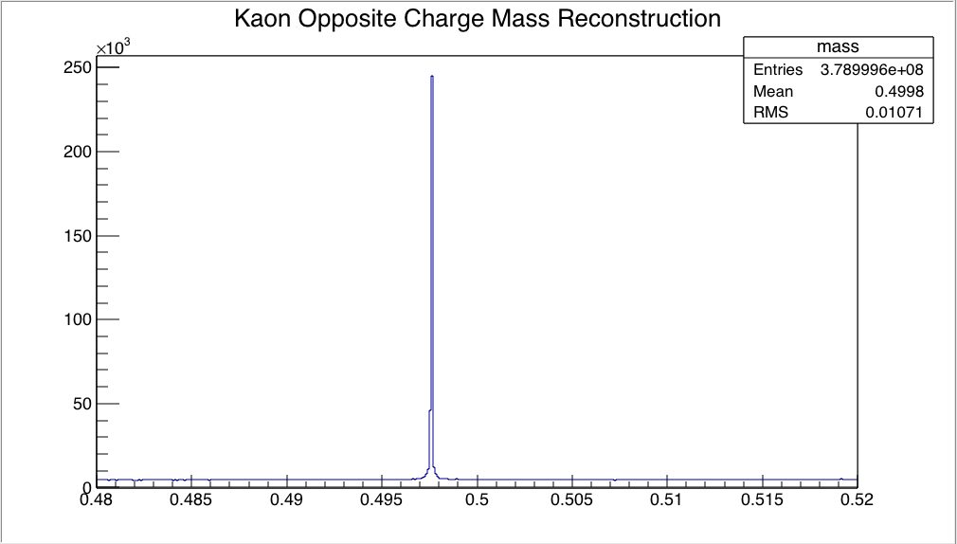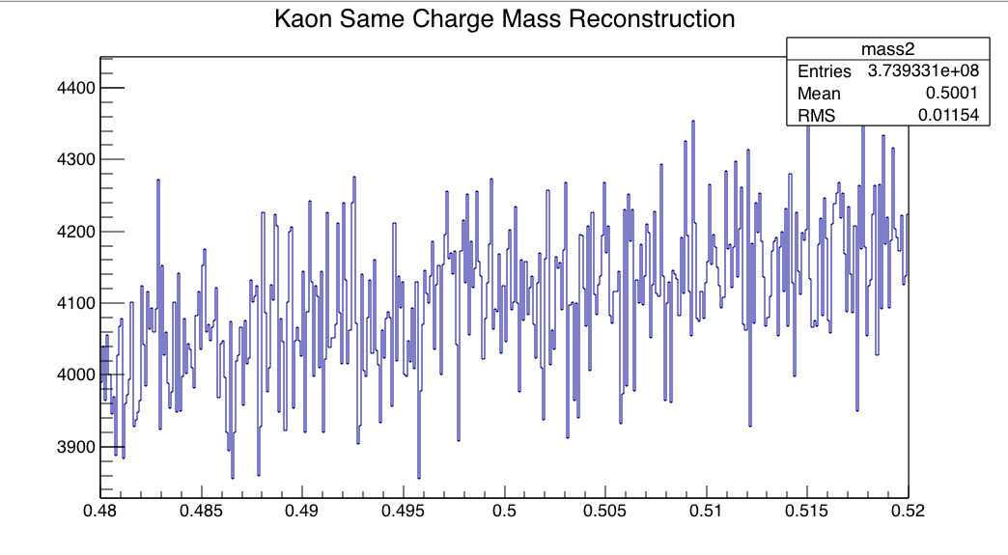

**Counts**

**GeV/c2**

**GeV/c2**

Figure 1: Kaon mass reconstructed from negative, negative or positive, positive charged pion pairs

Figure 2: Kaon mass reconstructed from negative positive pion pairs, the peak corresponds to K0S

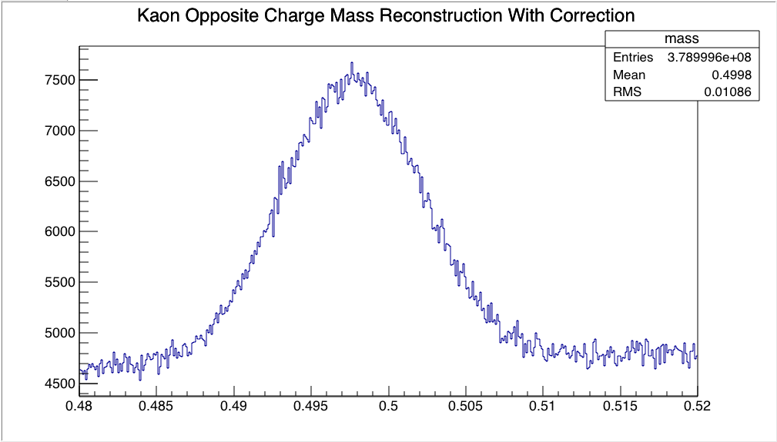

**Counts**

**GeV/c2**

Figure 3: Kaon mass reconstructed from negative positive pion pairs with simulated momentum reconstruction uncertainties. The peak corresponds to K0S.

K0S Mass Reconstruction

**Counts**

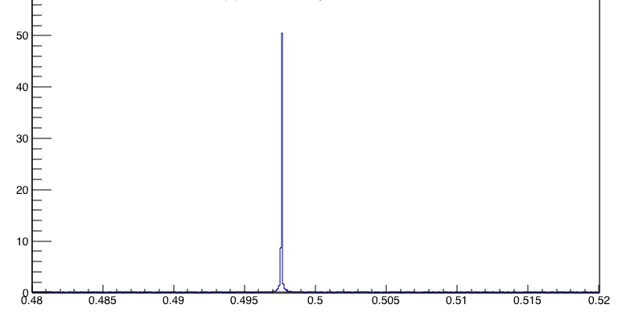

**GeV/c2**

Figure 4: Kaon mass reconstruction with background, which is same charge pions, subtracted from signal, which is oppositely charged pions. The peak corresponds to K0S.

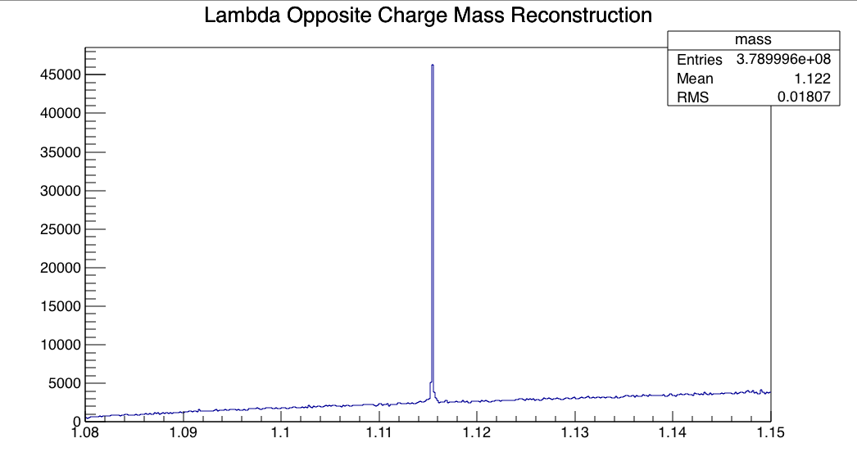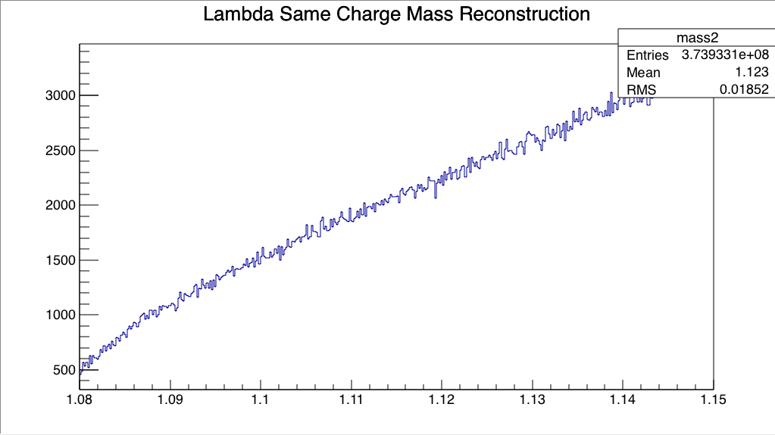

**Counts**

**Counts**

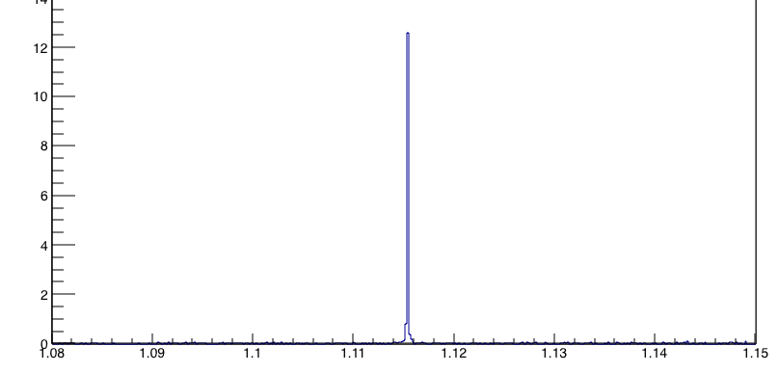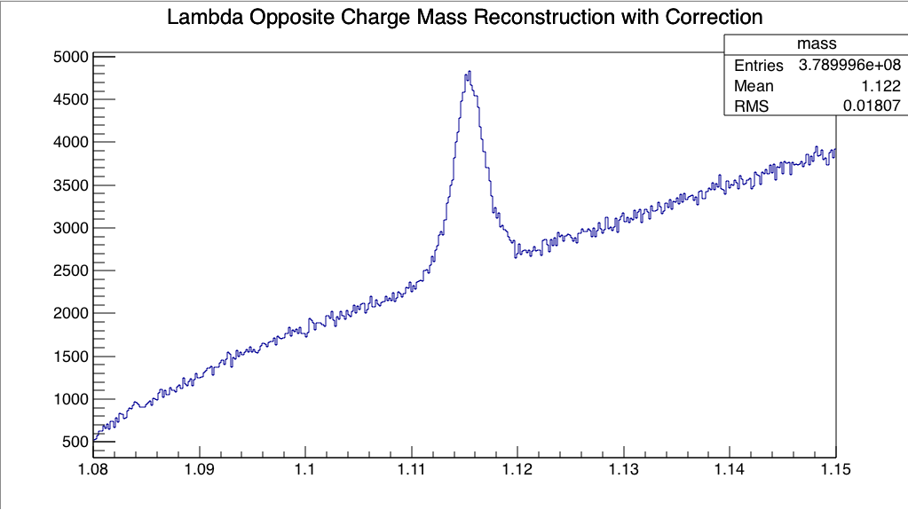

**Counts**

**GeV/c2**

**GeV/c2**

**Counts**

**GeV/c2**

**GeV/c2**

Figure 8: (below) Lambda mass reconstruction with background subtracted from signal. The peak corresponds to Λ

Figure 5: Lambda mass reconstructed from negative, negative or positive positive charged pion proton pairs.

Figure 6: Lambda pass reconstruction from oppositely charged pion proton pairs. The peak corresponds to Λ.

Figure 7: (right) Lambda mass reconstruction from opposite proton pion pairs with simulated momentum uncertainties. The peak corresponds to Λ

Λ Mass Reconstruction